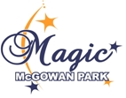
McGowan Park Elementary is now on Facebook!

Please click https://goo.gl/4Yg8fs to check us out!
'Like us' on our school website at http://mcgowan.sd73.bc.ca/
Or use your QR reader:
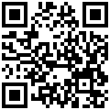

Bringing you all the news and activities of our school to your fingertips! :)

